Exergy Analysis of Waste Heat Recovery Cogenerative Organic Rankine Cycle

Abid Ustaoglu^{1 *}, Hande Torlaklı², Ertugrul Erdogmuş³, Alper Ergün⁴

¹Department of Mechanical Engineering, Bartin University, Bartin, 74100,Turkey
²Institute of Science and Technology, Bartin University, Bartin, 74100, Turkey
³Department of Environmental Engineering, Bartin University, Bartin, 74100, Turkey
⁴Department of Energy Systems Engineering, Karabük University, Karabük, Turkey

*abidusta@gmail.com, austaoglu@bartin.edu.tr

Abstract

Conventional technologies used to generate electricity from heat require high temperature and pressure values. This leads to some technical and economic difficulties. With the effect of industrialization, improvements have been achieved in the world's heat utilization technologies. One of the preferred methods for generating electricity from heat sources at low temperatures, such as waste heat, is Organic Rankine Cycle (ORC). In ORC systems, fluids with a high molecular weight and boiling point lower than water are used as working fluids. Electricity is produced by transferring energy in the waste heat to the organic fluid used in ORC system. In ORC systems, where only electricity is produced, significant losses occur which result in reduced efficiency during the conversion of waste heat. Unlike conventional power generation facilities, cogeneration systems, where simultaneous generation of heat and electricity can be realized, enable the utilization of produced heat energy and make the most efficient use of fuel energy. In this study, exergy analysis of cogenerative ORC system was performed in the Engineering Equation Solver (EES) program. Effect of using different input parameters and working fluids on the irreversibility values ​​of cogenerative ORC system components was determined.

Keywords – Waste heat, Cogeneration, Organic rankine cycle, Working fluids. Exergy

- Introduction
The production and consumption of energy, which is one of the most important criterias of national development, is among the issues that need to be considered and solutions for existing problems should be developed (Akdeniz, İlhan, Üçgül, Acar & Bayhan,2007). Due to the limited reserves of fossil resources that provide a large part of the global energy demand, fuel prices have increased and these sources have negative impacts such as greenhouse gas emissions and ozone depletion in the ecology, making energy efficiency one of the main issues that concern the world agenda.
One of the methods used for efficient use of energy is to recover the energy of waste heat. Waste heat is defined as the temperature in the exhaust gas caused by chemical reactions such as combustion. In most industrial processes, only a certain portion of the heat can be used. The remainder is mostly discharged into the atmosphere by flue gases. Electricity can be produced by using these waste heat in various systems. Recycling of waste heat plays an important role both in obtaining clean, cheap and reliable energy by reducing primary energy consumption and in decreasing dependence on energy by providing efficient use of resources (Çomaklı, Yüksel, Şahin & Karagöz,2006;Erdem, 2010).
In the processes, some of the heat is discharged to the atmosphere by the flue gas from the surfaces of the boilers which are the elements used to transfer the fuel energy to the working fluid in the system. With the effect of flue gases thrown into the atmosphere, 20% of the combustion energy can be lost in boilers (Terhan, 2015). Today, many methods are used in waste heat recovery. One of these methods is the direct utilization of waste heat without the use of any heat exchanger. Preheating can be done by mixing the waste flue gases directly with the combustion air or by using these gases in the process raw material drying. Although direct utilization of waste heat provides advantages over other methods in terms of easy applicability and economy, it has significant drawbacks limiting usability. When direct use is not applicable, another method of evaluating waste heat is to send exhaust heat to a heat exchanger (Dalkılıç, Alpay & Demir,2008). Alkhamis, Alhusein & Kablan (1998), stated that more than 60% of the waste heat generated in the kitchen oven can be recovered with the heat exchanger system they designed and this method is economical in their studies which evaluated the waste heat recovery potential of the Mutah University campus,
One of the systems used to generate electricity from low temperature sources such as waste heat sources is ORC. ORC systems differ from the known rankine cycles in that organic fluids are used as working fluids that pass from the water to the vapor phase at a lower temperature and can reach high pressures. The energy of the heat source at sufficient temperature and flow rate is transferred to the organic fluid in the ORC system (Ustaoglu,, Okajima,, Zhang & Maruyama,2015; Ergün, Özkaymak & Kılıçaslan,2016). In his thesis, Yinanç (2017) performed a performance analysis for different working fluids of an ORC using waste heat generated by incineration of landfill gas as heat source. Thermal and exergy efficiency of four different systems, namely, simple ORC, ORC with heat exchanger, ORC with open feed fluid heater and two-stage ORC were evaluated. As a result of the study, the highest thermal efficiency value was obtained from ORC with heat exchanger using R600 fluid as 13.8% and the highest exergy efficiency was 55% in all systems using R600 fluid.
In traditional systems where electricity is produced, large losses occur during energy conversion and transport of the produced energy to the place where it is consumed. Cogeneration systems, where electricity and heat can be produced simultaneously, provide an advantage over conventional systems in terms of energy efficiency by converting most of the heat energy to be released to the atmosphere in terms of both the production of energy in the place where it is consumed and the energy to be released to the atmosphere. Yağlı, (2018) examined the waste heat recovery of the heat-power combined engines (CHP) of a plant in Belgium that produces biogas using domestic waste in his thesis, Performance comparison of regenerated and non-regenerated ORC systems using R245fa as working fluid was made. As a result of energy and exergy analyzes, it has been seen that the use of regenerators reduces system performance in low temperature heat sources and it is more appropriate to choose a simple ORC system for designing a heat recovery system with maximum performance at minimum cost.
In this study, exergy analysis was carried out to determine the effect of different input parameters and working fluids on the irreversibility values ​​of the components in the cogenerative ORC system using the waste heat generated by industrial processes as heat source. The study contributes to the evaluation of the energy source, where most of it cannot be used, and to reduce the ecological problems caused by these gases

2. MATERIALS AND METHODS
2.1 System Performance Analysis

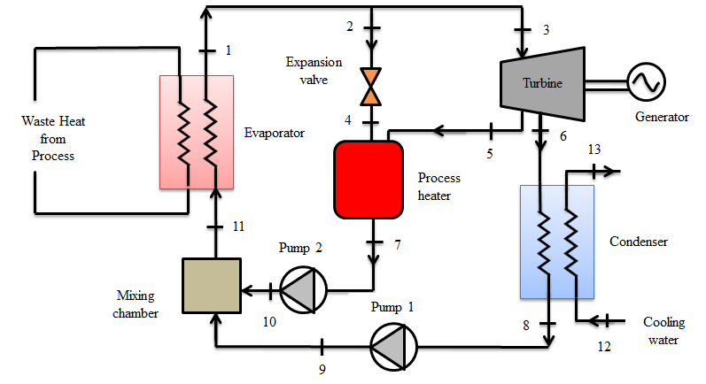

Figure 1. Waste Heat Recovery Cogenerative Organic Rankine Cycle

Figure 1 shows the cogenerative Organic Rankine Cycle using the waste heat generated by industrial processes as the heat source. For normal operating times, a portion of the steam exiting the evaporator in the combined heat-power plant is separated from the turbine at a designated intermediate pressure for use in heat treatment. After the rest of the steam is expanded to the condenser pressure, cooling is carried out at constant pressure. The pressure of the working fluid separated from the condenser is increased to the pressure of the evaporator compressed by the pump.In case the process load is high, a part of the steam exiting the evaporator is sent to the process-heater after it is expanded by a check valve or pressure reducing valve (PRV). The maximum process heat obtained from the system is obtained by passing all the steam exiting the evaporator through the pressure reducing valve. Power generation is 0 for this case. When the process temperature is not required, all steam is directed to the turbine and condenser. This time the cogeneration system works like a steam power plant.

The first law efficiency of the cogenerative ORC system can be calculated as follows:

(1)

and are respectively the heat supplied to the system from the heat source and the process heater, is the heat exiting the condenser. is the net work obtained from the system and can be expressed as follows.

(2)

Here represents the work produced in the turbine and shows the energy consumed in the pump. The exergy efficiency of the heat,ORC and overall system are respectively stated as follows:

(3)
(4)

(5)

In the equations, is the exergy input from the exhaust gas to the ORC system and is the exergy of process heater.
Different working fluids used in ORC systems have been evaluated in the literature. As a result of the evaluations, R113 and R123, which are dry and isentropic in Table 1, were selected as the working fluid. Analyzes were performed using EES program. The analyzes were carried out with the assumption that 10% of the steam exiting the evaporator was sent to the process heater before entering the turbine and 70% of it was expanded to the interval pressure in the turbine and then sent to the process heater. In order to facilitate the calculations, the following assumptions are taken into consideration. Both kinetic and potential energy changes in the system, heat loss and pressure drop in the pipes were neglected. Each component was considered to be stable. Isentropic yields of adiabatic turbines and pumps are assumed to be 85%. Heat loss in the environment and pressure drop in the pipes are neglected. It is assumed that the working fluid at the pump inlets is saturated liquid. The dead state temperature T₀ and the pressure P₀ are assumed to be 25°C and 101.325 kPa, respectively.
Table 1. Physical,Safety and Environment Properties of the Working Fluids (Calm & Hourahan,2011)

Component | Fluid type | T_{CR}  (°C) | P_{CR} (MPa) | MW (kg/kmol) | ODP | GWP  (100 yr)
R113 | Dry | 214.1 | 3.39 | 187.38 | 0.0850 | 6130
R123 | Isentropic | 183.7 | 3.66 | 152.93 | 0.010 | 77
T_{CR}=critical temperature; P_{CR}=critical pressure; MW=molecular weight ; ODP=ozone depletion potential; GWP=global warning potential

Table 2. Input parameters to the cogenerative ORC system

Parameter | Value
Inlet temperature of exhaust gas | 150°C.
Cooling water temperature at the condenser | 24°C
Mass flow rate of the exhaust gas | 5 kg/s
Pump1,2 isentropic efficiency | 85%
Turbine isentropic efficiency | 85%
Mass flow rate of the working fluid | 5 kg/s
Evaporator pressure | 1400 kPa
Interval pressure | 500 kPa
Condenser pressure | 150 kPa

3. Results and Discussion
Figure 2 shows the variation of heat exergy efficiency according to evaporator pressure for the selected working fluids. The input parameters were accepted as indicated in Table 2 and the evaporator pressure was changed to a calculation parameter. As the pressure change increases, the efficiency of the heat exergy decreases up to 800 kPa for both fluids and after this pressure value, exergy efficiency is not affected much by the pressure change. The total reduction in heat exergy efficiency is about 3.7% and 2.1% for R123 and R113 fluids, respectively.
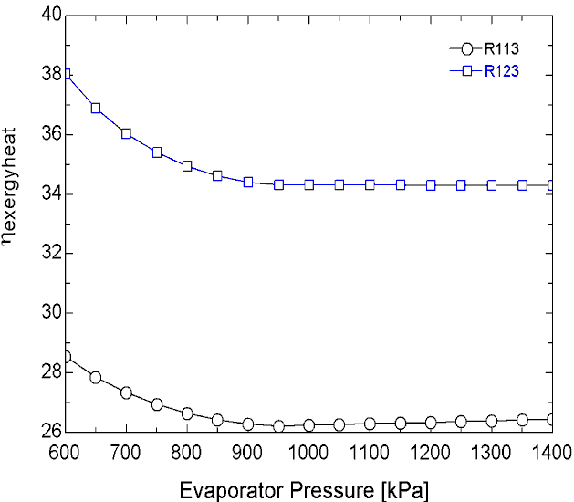
Figure 2. Variation of heat exergy efficiency according to evaporator pressure

Figure 3 shows the variation of exergy efficiency of the ORC according to the evaporator pressure. With the increase in evaporator pressure, ORC exergy efficiency increases up to 850 kPa and ORC exergy efficiency reaches maximum value at this pressure in systems using R123 and R113 fluids. The maximum ORC exergy efficiency theoretical value for R123 and R113 fluids is 26.75% and 19.48%, respectively. After a pressure of 850 kPa, the exergy efficiency decreases for both fluids and falls below the initial value after 1250 kPa for the R113 fluid.
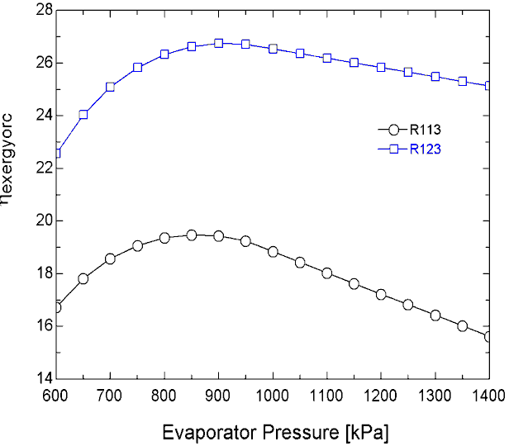
Figure 3. Variation of ORC exergy efficiency according to evaporator pressure

Figure 4 shows the exergy efficiency of the cogeneration system according to evaporator pressure. As the pressure difference increases, due to the higher compression in the pump up to about 800 kPa, more energy is generated in the turbine and the exergy efficiency of the cogeneration system increases for both fluids. However, as the pressure difference increases, the required pump power increases, so the evaporator pressure increase has a slight effect on the exergy efficiency of the cogeneration system. In the pressure range 800 kPa and 1400 kPa, the cogeneration efficiency is reduced from 60.06% to 59.43% for the R123 fluid and from 45.28 %to 42.2% for the R113 fluid.
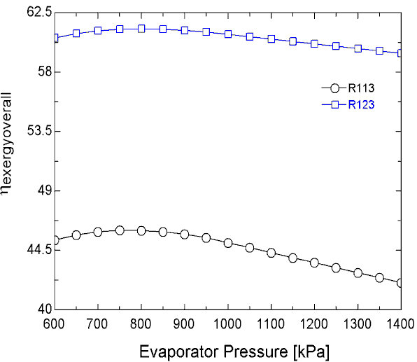
Figure 4. Variation cogeneration exergy efficiency according to evaporator pressure
4. Conclusion
The best performance in terms of exergy efficiency was observed for the working fluid isentropic R123.The evaporator pressure elevation decreases the heat exergy efficiency of R123 and R113. At a pressure of 800 kPa, heat exergy efficiency reduces for both fluids and after this pressure value, the heat exergy efficiency is not affected much by the change.The exergy efficiency of R123 is about 8% better.The evaporator pressure elevation rapidly increases the ORC exergy efficiency for both fluids up to 850 kPa pressure, whereas after this pressure there is a decrease in exergy efficiency The maximum exergy efficiency increase is about 3% and 4% for R113 and R123 fluids, respectively.While the overall exergy efficiency increases for both fluids up to 800 kpa pressure, it decreases to exergy after this pressure.The pressure elevation is the most effective for the working R123.The optimum working pressure of the system for exergy efficiency when both fluids are used is approximately 850 kpa.

Acknowledgements
This present work was developed within the the framework of a research project having ID 2018-FEN-A-014 fully funded by Bartın University, Bartın University Scientific Research Projects Coordinator (BAP) . The authors would like to thank Bartın University , BAP for the financial support given to the project.

References
Akdeniz, N., İlhan C.D., Üçgül İ.,Acar M. ve Bayhan M., 2007. Doğal gazlı kojenerasyon sisteminin termodinamik analizi ve Süleyman Demirel Üniversitesi örneği. VIII. Ulusal Tesisat Mühendisliği Kongresi, İzmir.
Alkhamis, T.M., Alhusein M.A. and Kablan M.M., 1998. Utilization of waste heat from the kitchen furnace of an enclosed campus. Energy Conversion and Management, 10, 1113- 1119.
Calm, J.M and Hourahan, G.C.,ICR 2011,August 21-26-Prague,Czech Republic, Physical, safety, and environmental data for current and alternative refrigerants.
Çomaklı, K., Yüksel B., Şahin B. ve Karagöz Ş., 2006. Kazan bacalarında meydana gelen enerji ve ekserji kayıpları. Tesisat Mühendisliği Dergisi, 92, 12- 16.
Dalkılıç, A.S., Alpay N. ve Demir H., 2008. Bir fırına ait bacadan ısı değiştirici yardımıyla atık ısı geri kazanımı. Tesisat Mühendisliği Dergisi, 108, 5-11.
Erdem, H. H. (2010). R6.1 Termik Santral Atılan Enerji El Kitabı, Yıldız Teknik Üniversitesi Makine Fakültesi İstanbul.
Ergün, A.,Özkaymak,M. ve Kılıçaslan,E., 2016. Organik Rankine Çevrimi Prensibi ile Düşük Sıcaklıktaki Kaynaklardan Elektrik Üretim Uygulamaları. Düzce Üniversitesi Bilim ve Teknoloji Dergisi, 4,686-696 .
Terhan ,M., 2015. Doğalgaz yakıtlı bir kazanda baca gazından enerji geri kazanımı ve yoğuşma olayının enerji, ekserji ve ekonomik yönden incelenmesi / Investigation in terms of energy, exergy and economical of water vapour condensing and energy recovery from flue gas in a natural gas fired boiler.Doktora Tezi , Atatürk Üniversitesi Fen Bilimleri Enstitüsü ,Erzurum.
Ustaoglu,, A., Okajima, J., Zhang, X.R. ve Maruyama, S.,2015. Evaluation of an Organic Rankine Cycle Using a Non-Imaging Solar Concentrator for Different Working Fluids, APJES III-III 01-07
Yağlı ,H., 2018. Basit ve Rejeneratif Organik Rankine Çevrimi (ORC) Tasarımları Kullanılarak Biyogaz Yakıtlı Isı-Güç Kombine (CHP) Motorunun Atık Isısının Geri Dönüştürülebilirliği, Enerji ve Ekserji Analizi/ Recoverability of The Waste Heat of A Biogas Fulled Combined Heat and Power (CHP) Engine by Using Simple and Regenerative Organic Rankine Cycle (ORC) Designs, Energy and Exergy Analysis.Doktora Tezi , İskenderun Teknik Üniversitesi Fen Bilimleri Enstitüsü ,Hatay.
Yinanç, S., 2017. Organik rankine çevrimi kullanılarak biyogaz tesisi atık ısısından elektrik enerjisi elde edilmesi / Electricity generation from biomass plant waste heat using organic rankine cycle. Yüksek Lisans Tezi, Erciyes Üniversitesi Fen Bilimleri Enstitüsü, Kayseri.

